M/s. Arope Insurance – M/s. Net Freight – Missing Shipment

ULA reference: 250616 – 1v1
Applicant’s Name: M/s. AROPE Insurance
Policy Holder: M/s. Skynet sal &/or Net Logistics sal &/or Net Logistics Jordan &/or Net Freight &/or Net Critical
Assured’s Name: M/s. Interbrands
Policy No.: OPN/1241983/ End. No. 38867
31 December 2025


It’s about time you receive the quality of service and expertise your firm deserves.


Document Control Page
Written By: | Reviewed by: | Approved by:
Estefani Haddad | Annie Abdel Massih | Petro Zaarour
Designation: | Designation: | Designation:
Claims Administrator | Claims Director | UK&I Chartered Engineer,  Average & Loss Adjuster
Signature (Approver)
This survey and its issued report were completed without prejudice to all rights of parties concerned .
Date of approval
31 December 2025

Version History | Date of issue | Reason for Revision
1 | 31 December 2025 | Issued - Final
The contents of this report are for the confidential information of the client
This survey and its issued report were completed without prejudice to all rights of parties concerned and its concluded adjustment is in accordance with the terms and conditions of the relevant insurance policy.
Report and adjustment note
At the request of M/s. AROPE Insurance (the Insurer), ULA was requested to investigate a claim (carried by land transit) for M/s. Net Freight (policyholder) & M/s. Interbrands (the Assured) and validate it on the subject policy. Table 1 is a summary with details pertaining to this claim.
The policyholder is a global provider of comprehensive logistics and transportation solutions and has acted for the subject cargo claim as its Freight Forwarder. From discussions with the Insurer, the policy is understood to have been taken out for the benefit of the Assured. The contract of carriage nature between the Policy Holder and the Assured is yet to be ascertained.
It should be noted that the Assured / Notify party (M/s. Interbrands) is a leading distributor of international consumer goods, including personal care, cosmetics, and household products, based in Amman, Jordan, as declared by the policy holder.
Table 1 - Summary and salient details
Insurance Policy | No. OPN/1241983/ End. No. 38867  CL 382 - Clause (A) as confirmed with the Insurer  Warehouse to Warehouse  Basis of valuation: Invoice value + 10%  Sum Insured: Invoice Value +10% =USD 47,532.00  Warranted Professionally & Adequately Packed & Lashed.
Assured’s / Consignee’s Name | M/s. Interbrands, Amman, Jordan
Incoterm | EXW as per invoice No. JOD003/2025 issued by M/s. MIRATO MEA dated 28.04.2025.
Shipper’s Name | M/s. MIRATO MEA, Lebanon
Cargo Commodities | 3,031 boxes of Deodorants/ Bath foam – Gross Weight: 29846.00 KGS.
Truck Waybill No. | 73/2022 issued by M/s. Forwarders Lebanon dated 09.05.2025
Trailer No./ Driver’s Name | 352184/L / Mr. Feisal Dib

INTEREST INSURED & RELEVANT CONDITIONS OF INSURANCE
3,031 boxes of Deodorants/ Bath foam shipped from Lebanon to Amman, Jordan by land, under policy No. OPN/1241983/ End. No. 38867; Sum insured: Invoice Value +10% =USD 47,532.00, Clause (A), Warehouse to Warehouse.

ADJUSTER NOTES
- The cargo, consisting of 3,031 boxes, was transported from Lebanon to Amman, Jordan by land, onboard trailer No. 352184/L, driven by Mr. Feisal Dib.
- Upon cargo delivery to the Consignee’s premises (M/s. Interbrands) located in Amman, Jordan, the unloading process revealed that 165 items were missing, and 13 items were damaged (see claim form enclosed).
- A Proof of Delivery (POD) dated 19 May 2025 confirmed that the container seal was received intact; however, the following shortages were noted upon delivery: 1 carton of 1 Litter men shampoo missing 12 pieces, and 14 cartons of deodorants missing a total of 168 pieces (copy enclosed).
- Following the identification of the shortages and damages, ULA was requested to investigate the circumstances surrounding the loss and damage sustained during the insured transit.
- As part of the investigation, ULA requested supporting documents, including the border entry form, pre-loading photographs, images of the cargo inside the trailer, and photographs of the cargo at borders. The requested document and photographic evidence, however, were not made available by the concerned parties.
- Upon review of the photographic evidence of the cargo condition at destination (Figure 1 refers), the following observations were made:
- Several cartons exhibited visible signs of liquid exposure, including staining & dampened surfaces;
- A number of cartons were found torn, crushed, and structurally deformed;
- Some cartons showed loss of rigidity and weakened carton integrity.
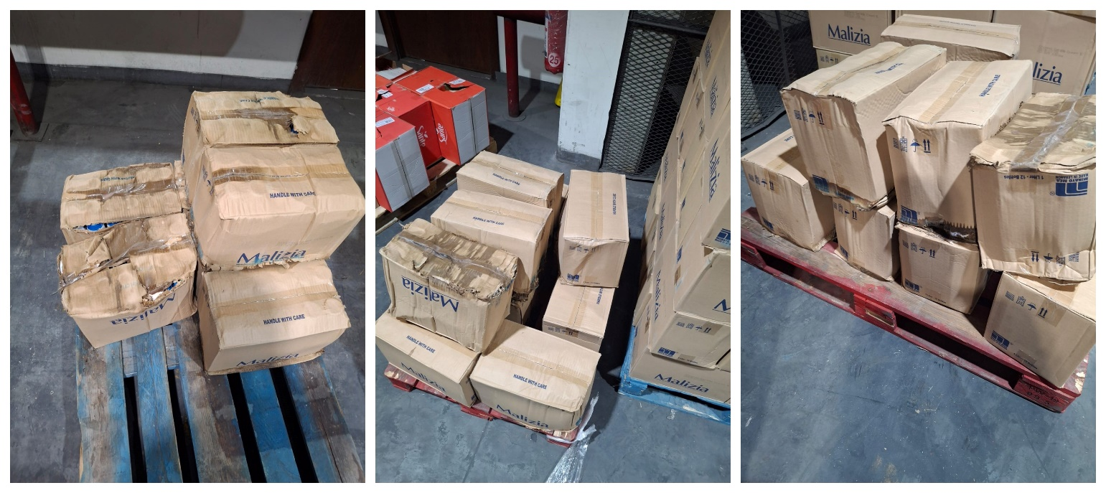
Figure 1 - Photographs of the cargo at the final destination
- Following the completion of segregation of the delivered cargo, it was noted that 13 items were damaged and 165 items were missing from the original consignment.
- On completion of our investigation, we were able to confirm that the Assured complied with the policy warranties and conditions.

CAUSE OF LOSS
The proximate cause of loss is cargo theft, which is likely to have occurred during transit while the insurers were still on risk. Damage to the cargo is thought to have been caused by rough or unauthorized handling, or by the forceful removal of the cargo, making it a consequence of theft.
Since there isn’t any damage report issued by customs, it is most probable that the theft occurred while the cargo was in the custody of the contracted hauler (Mr. Feisal Dib) by the policy holder, M/s. Net Logistics.

CLAIM & ADJUSTMENT (BOV – INVOICE + 10%)
On receipt of invoice No. JOD003/2025 issued by M/s. MIRATO MEA dated 28 April 2025 (copy attached), the claimed policy indemnity and its adjustment are listed Table 2 below:

Table 2 - Claim and adjustment
Description | Quantity | Unit Price (2% discount as per invoice) | Total Amount in USD
Missing Items
Malizia FC Dry 150ML | 144 | USD 1.15  after discount  USD 1.13 | 144 x USD 1.13 = USD 162.72
Malizia FC Green Tea 150ML | 4 | USD 1.15  after discount  USD 1.13 | 4 x USD 1.13 = USD 4.52
Malizia FC Neutral 150ML | 2 | USD 1.15  after discount  USD 1.13 | 2 x USD 1.13 = USD 2.26
Malizia FC Talc 150ML | 7 | USD 1.15  after discount  USD 1.13 | 7 x USD 1.13 = USD 7.91
Malizia S/G Coconut Milk 1L | 8 | USD 1.34  after discount  USD 1.31 | 8 x USD 1.31 = USD 10.48
Damaged items
Malizia S/G Coconut Milk 1L | 4 | USD 1.34  after discount  USD 1.31 | 4 x USD 1.31 = USD 5.24
Malizia S/G Aloe and Magnolia 1L | 1 | USD 1.34  after discount  USD 1.31 | 1 x USD 1.31 = USD 1.31
Malizia S/G Talc 1L | 2 | USD 1.34  after discount  USD 1.31 | 2 x USD 1.31 = USD 2.62
Malizia S/G Talc 400ML | 6 | USD 0.65  after discount  USD 0.64 | 6 x USD 0.64 = USD 3.84
Adjusted Claim Amount --------------------------------------------------------------------------------------- USD 200.90
Uplift, 10% as per relevant policy---------------------------------------------------------------------------USD 220.99
Say, U. S. Dollars Two Hundred Twenty & 99/100 Only.

CONCLUSION
In our opinion,
- The claimed loss of USD 220.99 is considered fair and reasonable.
- The goods were adequately insured at the time of loss, with no evidence to suggest underinsurance;
- The nature of the Assured’s activity is consistent with that declared;
- The mode of conveyance in the policy is established to be for land shipments. As such, the loss is recoverable under clause (A) as a fortuitous loss by theft, occurring whilst insurers were on risk (EX-Works terms of sale);
- The loss is likely to have occurred during customs inspections at borders and/or whilst in the custody of M/s. Net Logistics SAL (policyholder) as bailee, before delivery to the consignee, possibly taking advantage of the situation at the borders.
- As such, Insurers, at their discretion, should consider whether they are satisfied with the level of evidence presented and whether they wish to pursue a claim recovery against the liable hauler, noting that the claim amount may render such efforts uneconomic.
We confirm sighting the originals of all received documents (see enclosed), made available in support of a claim of this nature.
End of adjustment note.
Enclosed Documents

- Insurance policy No. OPN/1241983/ End. No. 38867
- Truck Waybill
- Consignment Note
- Claim form
- Invoice
- Packing List
- Proof of Delivery (POD)
- Land Transport Invoice
- Debit Note
- Detailed Claimed amount

Outstanding/ Not Available Documents:
- Jordanian border entry form
- Letter of reserve
- Delivery order / note
- Pre loading photographs (taken before cartons were shipped)
- Photographs of cargo inside trucks.
- Photographs taken at borders (if possible)
- Damage report issued at borders.

About ULA
United Loss Adjusters and Surveyors (ULA) is a leading international provider of Adjusters, Surveyors, Solicitors and Consultants, offering unrivalled technical and legal solutions with exclusive access to the London Market's leading specialists.
Founded in 2002, with strategic head offices in the Middle East and the United Kingdom, today ULA is the strategic ally of a world leading legal firm (with offices in over 60 major countries) and the correspondent for a number of global technical service providers (with offices in 140+ countries), with principals including but not limited to Insurers, Reinsurers, Brokers, P&I clubs, Ship Owners, Shipyards and Agencies.
Lines of business:
- Insurance & Re-insurance
- Claims solutions and loss adjusting across all major lines: aviation, cargo, marine, property, fine arts and special risks claims
- Cargo & Containers
- Marine & Offshore
- Global Claim Recoveries & Legal Support
Our team:
Our team of qualified professionals experienced in the fields of Marine, Insurance, Finance, Engineering and Law known and respected for their integrity and credibility. Supported by a highly mobile team strategically positioned where our services are needed, we are always available on short notice to deal promptly with your queries. ULA is independent to the core and can be trusted to express unbiased views, and is not influenced by stakeholders.
ULA’s team members are recognised:
- Chartered Engineers
- Consultants
- Inspectors & Auditors
- Insurance & Re-Insurance Underwriters
- Loss & Average Adjusters
- Master Mariners & Chief Engineers
- Naval Architects, Marine & Offshore Engineers
- Solicitors
- Sworn Surveyors
ULA’s team members are also recognised members of the following international institutions:
- The Association of Average Adjusters (AAA)
- The Bar Council of England and Wales
- The Chartered Insurance Institute (CII)
- The Chartered Institute of Loss Adjusters (CILA)
- The European Federation of Loss Adjusting Experts (FUEDI)
- The Institute of Fire Engineers (IFE)
- The Institute of Marine Engineering, Science and Technology (IMarEST)
- The UK Engineering Council
- The Royal Institute of Naval Architects (RINA)
- The International Institute of Marine Surveying (IIMS)
- The Royal Institute of Chartered Surveyors (RICS)

Contact person
Petro Zaarour
Director
United Kingdom: 71-75 Shelton Street, Covent Garden | London, England - WC2H 9JQ
Middle East: Mina Tower, Ain Waraka Street | Beirut, Lebanon - WG2G+5CX

Registered name United Loss Adjusters and Surveyors Ltd.

24/7 Contacts & Claim Support – T: +44 (0) 20 3287 3326 | M/WhatsApp: +44 (0) 7 375 110 573
Office E: mailto:claims@unitedlossadjusters.com
W: https://www.unitedlossadjusters.com/



